Introduction to Brain and Machine Learning (BNCS411)

**Assignment #6**

Due Date: 2021-12-12

**Objective**

* To train a model with both labeled and unlabeled datasets by utilizing pseudo-labeling, which is one semi-supervised learning technique.

**Dataset**

* The MNIST dataset contains 70,000 images of handwritten digits (zero to nine) that have been size-normalized and centered in a 28x28 square grid.

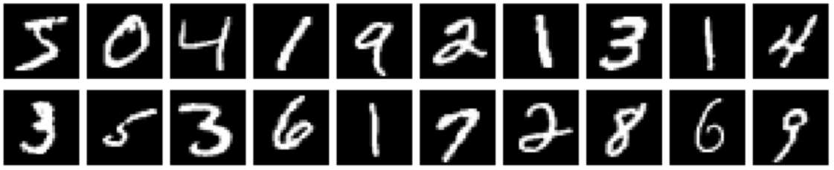

**Implementation Instructions**

* Write your codes in a given assignment file using the Google Colab.
* There is no limitation on the number of cells where you write the codes in the implementation section.
* Only allowed libraries that are stated in the file.
* Describe your codes and analysis by using markdown scripts.

(Example)

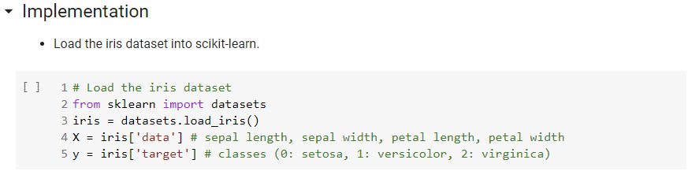

* **(IMPORTANT) Submit the *.ipynb file executed in the specified template.**
  + File name: “BDC114_Assignment_6_**yourID**.ipynb”

TA’s note: Beware of plagiarism (we use proprietary plagiarism checkers in addition to BlackBoard plagiarism checker). Ask the TAs if you have any questions.